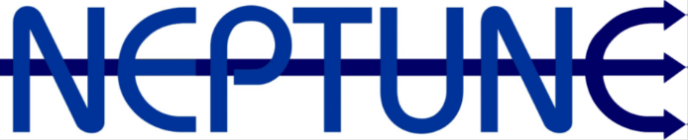
Officials Refund Form

Officials Name
Meet Name
Meet Date

- Must officiate ALL sessions at the meet
- Complete and submit an Officials Grant form, within two (2) weeks of the competition being held
- Once verified and following committee approval, payments will be made via internet banking (as per your instructions below)
- Capped at $500 per official in the current financial year

Position | In which sessions

Bank Account Name |  | Bank account Number

Club Administration Use:
Date Approved |  | Payment Date |  | Payment Amount

Email completed form to neptuneswimclub@gmail.com within 2 weeks of the completion of the meet, for committee approval and payment when verified

